**Frontend Development with Reaact.js**

**Project Documentation for Recipe app**

1. **Introduction**

* **Project Title : Cook Book- Recipe App**
* **Team members:**
* **SASIVANAN P M (Team Leader) [Email id:devil04sasi28** [**@gmail.com**](mailto:hajirasadhiq2@gmail.com)**]**
* **PRASATH B [Emailid:babuwelding1979@gmail.com]**
* **RAJA R [Email id:** **rraja14092005@gmail.com.]**
* **YOGANITHI R [Email id:** **shadow007yoga@gmail.com]**

1. **Project Overview**

* **Purpose:**

Cookbook is a web application designed to help users explore, view, and organize recipes. It provides a seamless experience for browsing recipes with images, categorized by cuisine, ingredients, and meal types.

* **Features:**
* Browse and view detailed recipes
* Search recipes by name, ingredient, or category
* Filter recipes based on cuisine, difficulty, or cooking time
* View high-quality images of recipes
* Responsive design for mobile and desktop

**PRE-REQUISITES**: Here are the key prerequisites for developing a frontend application using React.js:

**✓ Node.js and npm:** Node.js is a powerful JavaScript runtime environment that allows you to run JavaScript code on the local environment. It provides a scalable and efficient platform for building network applications. Install Node.js and npm on your development machine, as they are required to run JavaScript on the server-side.

• **Download**: <https://nodejs.org/en/download/>

**• Installation instructions**: <https://nodejs.org/en/download/package-manager/>

**✓ React.js:** React.js is a popular JavaScript library for building user interfaces. It enables developers to create interactive and reusable UI components, making it easier to build dynamic and responsive web applications.

Install React.js, a JavaScript library for building user interfaces.

• **Create a new React app:**

npx create-react-app my-react-app

Replace my-react-app with your preferred project name.

• **Navigate to the project directory**: cd my-react-app

**• Running the React App**: With the React app created, you can now start the development server and see your React application in action.

**• Start the development server:**

npm start This command launches the development server, and you can access your React app at http://localhost:3000 in your web browser.

**✓ HTML, CSS, and JavaScript**: Basic knowledge of HTML for creating the structure of your app, CSS for styling, and JavaScript for client-side interactivity is essential.

✓**Development Environment:** Choose a code editor or Integrated Development Environment (IDE) that suits your preferences, such as Visual Studio Code, Sublime Text, or WebStorm.

• **Visual Studio Code:** Download from <https://code.visualstudio.com/download>

**Get the Code:**

**3. Architecture**

**Component Structure:**

* Header: Navigation bar with search functionality
* Recipe List: Displays a grid of available recipes
* Recipe Detail: Shows the full recipe with ingredients and instructions
* Category Filter: Allows users to filter by meal type or cuisine

**State Management:**

* Using React **useState** and **Context API** to manage recipe data and filters

**Routing:**

* / - Home page with featured recipes
* /recipe/:id - Recipe details page
* /category/:type - Filtered recipes based on category

**4. Setup Instructions**

* Prerequisites:
* Node.js (v16 or higher)
* npm (v8 or higher)
* Git
* **Installation:**

1. Clone the repository:

git clone <https://github.com/Hajirasadhiq/Recipe_app>

1. Navigate to the client directory:

cd cookbook-app/client

1. Install dependencies:

npm install

1. Start the development server:

npm start

**5. Folder Structure**

**Client:**

* src/components - Reusable UI components (RecipeCard, Header, etc.)
* src/pages - Page components (HomePage, RecipeDetailPage)
* src/assets - Static assets like images
* src/context - Context API for managing global state
* App.js - Main application component
* index.js - Entry point

**6. Running the Application**

**Frontend:**

npm start

npm install

npxjson-server ./db/db.json

npm run dev

The app will be available at <http://localhost:3000>.

**7. Component Documentation**

* Key Components:

RecipeCard: Displays a recipe preview

* Props: recipe (object containing title, image, description)

RecipeDetail: Shows full recipe details

* Props: recipeId (used to fetch detailed data)

CategoryFilter: Allows filtering recipes

* Props: selectedCategory, onCategoryChange

**8. State Management**

* **Global State**: Managed using Context API for storing recipe data and filters
* **Local State**: Handled using useState within individual components

**9. User Interface**

* Screenshots of Home, Recipe Detail, and Filter Pages

**10. Styling**

* CSS Frameworks/Libraries: Using Styled-Components for styling
* Theming: Light and dark mode support

**11. Testing**

* **Testing Strategy:**
* Unit Testing: Using Jest and React Testing Library
* Integration Testing: Ensuring component interaction
* End-to-End Testing: Cypress for testing user workflows
* **Code Coverage:**
* Code coverage is monitored using Jest’s built-in tool

**12. Screenshots or Demo**

**User Interface Snips:**

* **Hero components**

The hero component of the application provides a brief description about our application and a button to view more recipes.

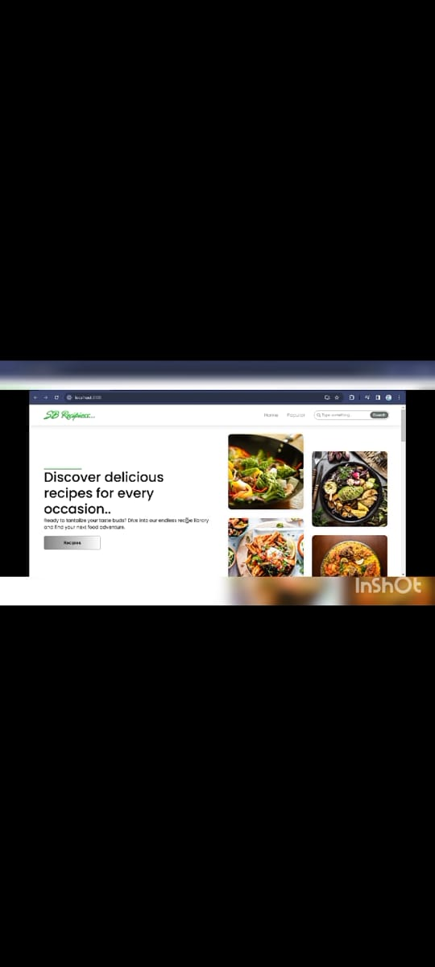

**➢Popularcategories**:

This component contains all the popular categories of recipes.

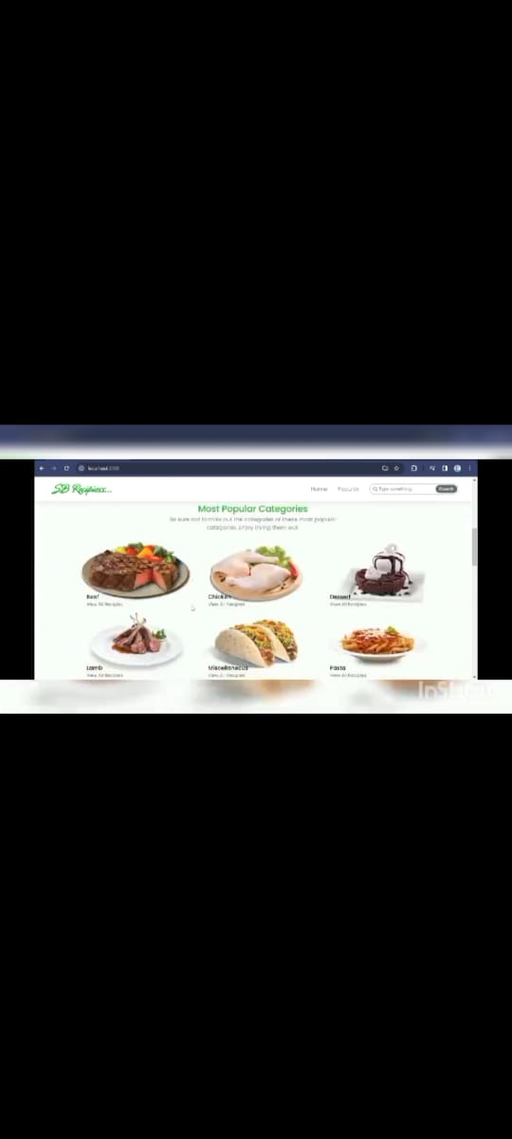

➢**Trending Dishes :**

This component contains some of the trending dishes in this application

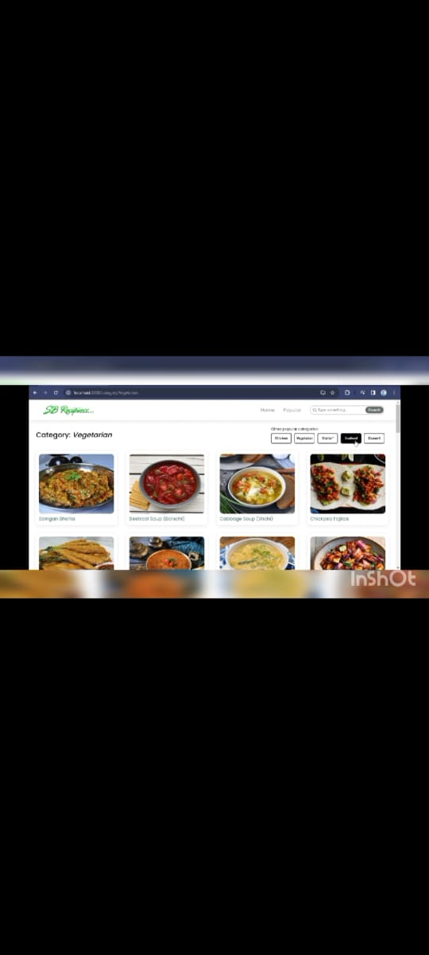

* **News Letter:**

The news letter component provides an email input to subscribe for the recipe newsletters.

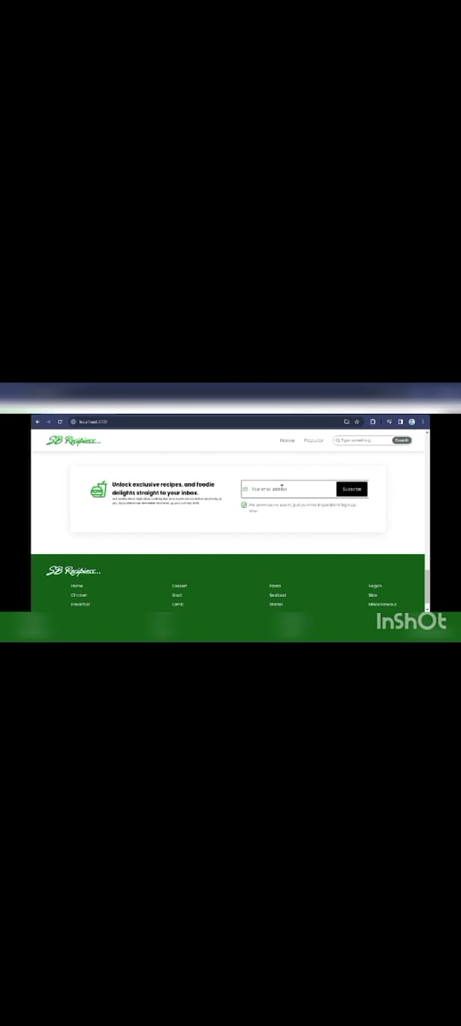

**➢ Category dishes page :**

The category page contains the list of dishes under a certain category.

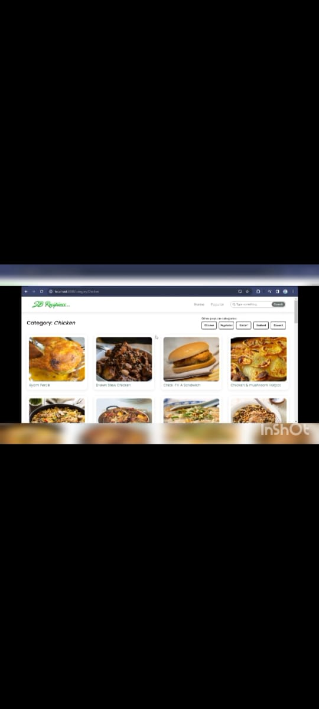

**➢ Recipe page:**

The images provided below shows the recipe page, that includes images, recipe instructions, ingredients and even a tutorial video.

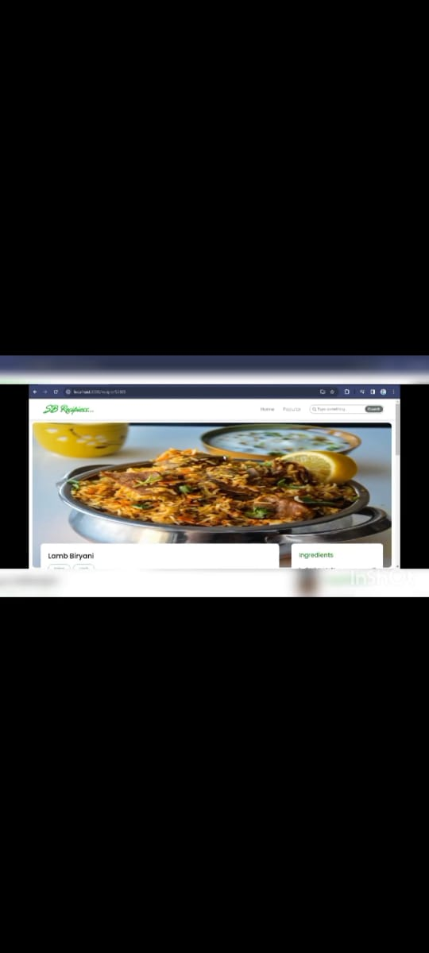

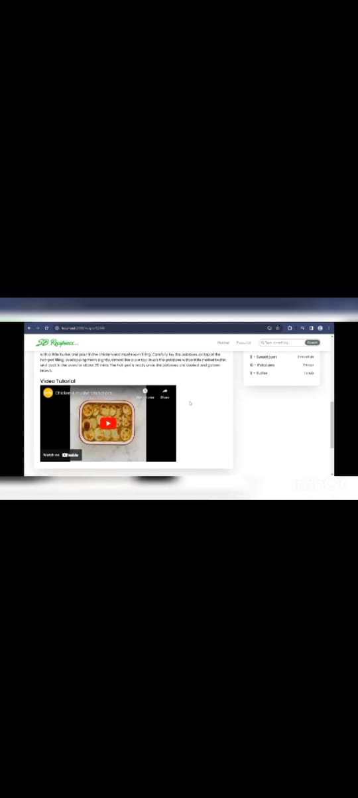

* **Demo Link:**<https://github.com/Hajirasadhiq/Recipe_app>
* Provided screenshots or a link to a working demo

**13. Known Issues**

* Issue 1: Some recipe images may take longer to load
* Issue 2: Search may need optimization for large datasets

**14. Future Enhancements**

* Add a favorites feature to save recipes
* Include step-by-step video tutorials for recipes
* Implement multi-language support for wider accessibility

**Project Structure**

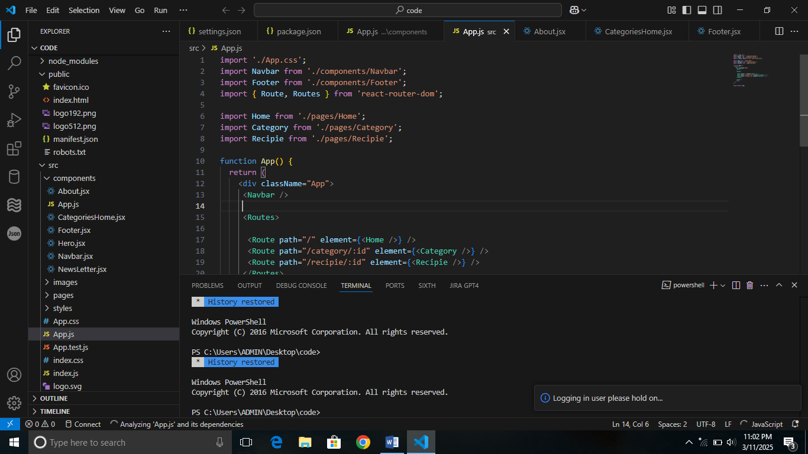

**Coding**



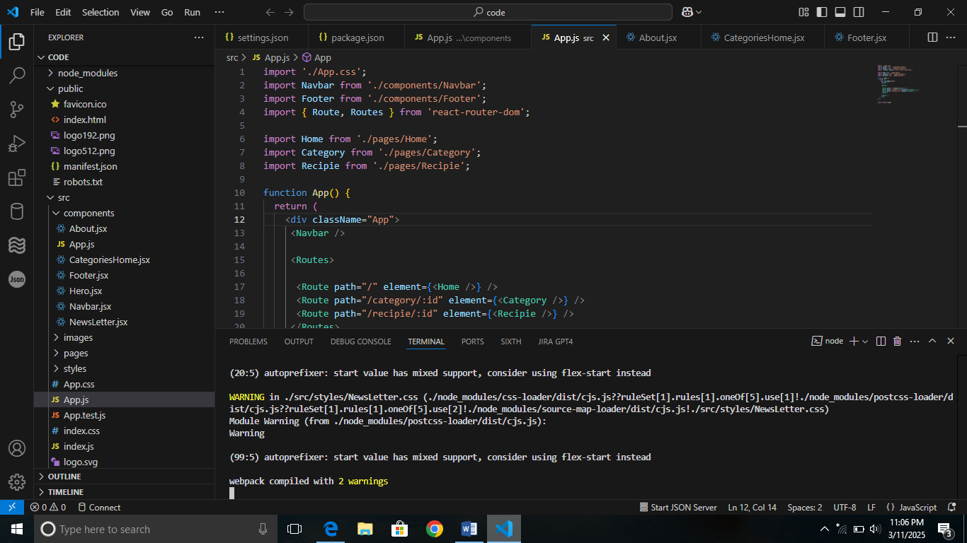

This documentation provides a comprehensive overview of the Recipe app project,including its architecture, setup instruction, and future plans.